Week 1 Study Aide for HCA 255 Health Policy and Economic Analysis Care class.
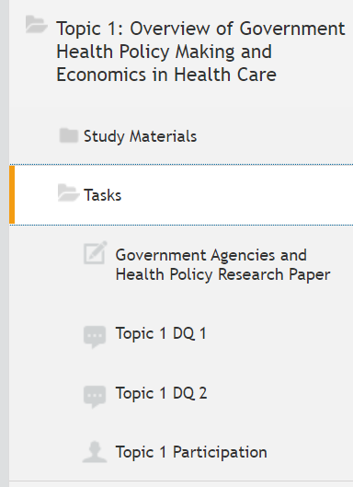
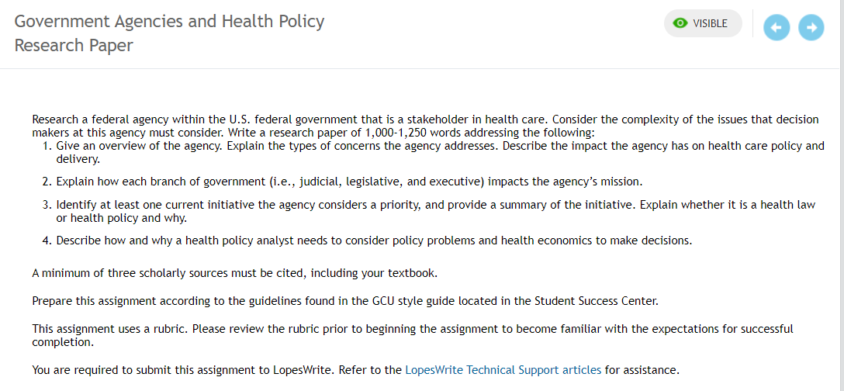
Government Agencies and Health Policy Research Paper
Good examples to use for this assignment are: the FDA, The U.S Department of Health and Human Services (HHS), Center for Disease Control and Prevention (CDC), Centers of Medical and Medicaid Services (CMS). the Agency for Healthcare Research and Quality. the Indian Health Service (IHS).
Research a federal agency within the U.S. federal government that is a stakeholder in health care. Consider the complexity of the issues that decision makers at this agency must consider. Write a research paper of 1,000-1250 (title and reference pages not included in word count) (it is ok to go over) words addressing the following:
1.Give an overview of the agency. Explain the types of concerns the agency addresses. Describe the impact the agency has on health care policy and delivery.
2.Explain how each branch of government (i.e., judicial, legislative, and executive) impacts the agency?s mission.
3.Identify at least one current initiative the agency considers a priority, and provide a summary of the initiative. Explain whether it is a health law or health policy and why. [Be sure to have some statistics to support your paper and your analysis for this. Scope and size are to include numbers such as dollar budget, number of employees, number of facilities or patients serviced are examples]

4.Describe how and why a health policy analyst needs to consider policy problems and health economics to make decisions. [Be sure to have some statistics to support your paper and your analysis for this.]
Recommended agencies: The U.S Department of Health and Human Services (HHS); CDC; U.S. Food and Drug Administration; Centers for Medicare and Medicaid Services, OSHA.
A minimum of three scholarly sources must be cited, including your textbook.
Prepare this assignment according to the guidelines found in the GCU style guide located in the Student Success Center.
This assignment uses a rubric. Please review the rubric prior to beginning the assignment to become familiar with the expectations for successful completion.
You are required to submit this assignment to LopesWrite. Refer to the LopesWrite Technical Support articles for assistance.
This is a very lengthy paper so get an early start on it.
A minimum of three scholarly sources must be cited. Be sure to have a clear research paper header that includes your topic. Also, have a strong introduction paragraph, purpose statement, and conclusion paragraph. Be sure to read your written assignment out load before submitting it to correct grammar and writing composition errors.
Prepare this assignment according to the guidelines found in the GCU Style Guide located in the Student Success Center.
This assignment uses a grading rubric. Please review the rubric prior to beginning the assignment to become familiar with the expectations for successful completion.
You are required to submit this assignment to LopesWrite. Please refer to the directions in the Student Success Center.
Key rubric grading criterial:
The essay provides a well-researched overview of the selected federal agency and explains the types of concerns the agency addresses. The essay expertly describes the impact this agency has on health care policy and delivery.
The essay expertly explains how each branch of government (judicial, legislative, and executive) impacts the mission of the agency.
The essay comprehensively describes one or more current initiatives the agency considers a priority and provides a thorough summary of the initiative. The essay expertly describes whether it is a health law or health policy.
The essay comprehensively describes how and why a health policy analyst needs to consider policy problems and health economics to make decisions.
Thesis is comprehensive and contains the essence of the paper. Thesis statement makes the purpose of the paper clear.
There is a sophisticated construction of paragraphs and transitions. Ideas progress and relate to each other. Paragraph and transition construction guide the reader. Paragraph structure is seamless.
Writer is clearly in command of standard, written, academic English.
All format elements are correct.
Sources are completely and correctly documented, as appropriate to assignment and style, and format is free of error.
A minimum of three scholarly sources must be cited, including your textbook. A research paper of 1,000-1250 (title and reference pages not included in word count) (it is ok to go over) words.
Be sure to include some statistics about the size and score of the information about this federal agency, current initiatives, problems and health economics.
-----
Remember that this is economics and health policy class. It is vital to use measures and numbers is the academic, critical-thinking analysis of health care. I specialize in health care economics so that may be a reason why I believe statistics and facts are important in studying health care systems. Having facts and empirical evidence to support the assertions in your paper are important. Empirical evidence relies on practical experience rather than theories. Empirical evidence is data and information obtained by creating assumptions over a specific topic, observing the collected data and experimenting to prove or disprove a theory.
It is important in writing college papers, to justify your comments and conclusions with concrete facts. Here is an example of the importance of using empirical evidence and statistics. It is important to get a clear understanding of the burden of disease. What is the amount of poverty in your country? Does families need public assistance? Is there good access to health care services (numbers if possible)?
What is the government doing to help the population regarding their health and access to health care services? It is good to get an idea of the amount of government money spent on health care and what % amount the total. What is the % of private vs government health care spending? Does the population rely on most of their care on the government or their own resources? What is the government’s current health care strategies and what are their future strategies?
[Be sure to have some statistics to support your paper and your analysis for this.] There should be some numbers or data on the health of the population. Find supporting data or information from articles supporting this. Is there a study or outside source supporting your assertions? It is difficult to study modern health care systems prudently without much supporting data and health care costs. What is the population’s health stats? A good thing to do would be to show the health stats of the country such as the top 5 causes of death with %’s as causes of death? These are all types of health statistics. Health statistics are numbers about some aspect of health. Statistics about births, deaths, marriages, and divorces are sometimes called "vital statistics." Researchers use statistics to see patterns of diseases in groups of people. ‘Health statistics by country’ and ‘public health system in ‘your country’ are good starting points in Google for your research for this assignment.
> I recommend that you use 1st level headers for written assignments in the class. Centered, Boldface, Title Case Heading
> For content, critical thinking analysis, and quality, I recommend at least 3 outside resources for your paper to improve its content and critical thinking content.
> Develop your critical thinking skills in your analysis in your paper. Critical thinking skills are extremely important in developing a successful career. Critical thinking is the intellectually disciplined process of actively and skillfully conceptualizing, applying, analyzing, synthesizing, and/or evaluating information gathered from, or generated by, observation, experience, reflection, reasoning, or communication, as a guide to belief and action (Defining Critical Thinking, 2015).
It is important to use data-driven decision-making concerning economic management decisions. Be sure to read the file that I posted on ‘How Can I Incorporate Evidence and Critical Thinking into my Paper?’, it will help you improve the quality of your essays. It is located in the ‘Questions to Instructor Forum’ area of our web class.

References
Defining Critical Thinking. (2015, October 28). Retrieved from Criticalthinking.org: http://www.criticalthinking.org/pages/defining-critical-thinking/766
----------
The grading rubric for this assignment is below.
**– Weekly Participation Grading Rubric - Key Grading Criteria.
*Two initial responses to the two discussion questions. (one response for each discussion question)
*At least two (2) posts to colleagues per discussion question. I recommend that you use 75 to 100 words on your text posts to colleague’s comments.
-Posts made on three separate days during the week with a first post by Wednesday.
*****Total: 20 possible points (6 total responses each week).

The grading rubric for this assignment is below.
**– Weekly Discussion Question Grading Rubric - Key Grading Criteria.
*Initial response to the discussion question which must be at least 125 words in length (reference page is not included in the word count).
*Content, substance, critical thinking analysis. An expert input thorough an outside source improves the academic quality of your posts. Use of an outside source to strengthen critical thinking analysis using complete APA formatting.
-Posted by the due date of the discussion question. See course calendar for the due date of the discussion question. They would be either day 3 or day 5 of the week.
*****Total: 5 possible points
-------
> Time commitment: All of the Grand Canyon University courses are designed to take 48 total hours to complete over the length of the course. In a 5 week course that would be about 9.6 hours per week. It is almost like a part-time job. Be sure to plan ahead to be able to make time to study because most of you have very busy lives and time is difficult to find.
Prov 29:23 Do you see a man who speaks in haste? There is more hope for a fool than for him.
Thank you and let me know if you have any questions.
Instructor Steve
Steve Klense, MPH, LNHA
Faculty
steve4545@cox.net
Prov 29:23 Do you see a man who speaks in haste? There is more hope for a fool than for him.
A Question from a student:
Hello Professor,
I am looking ahead at what needs to be done this week and I want to set up the template for my paper now so that once I do my research I can get started on it.
I recommend that you use the weekly study aides that I post in the Announcements each week and you should be able to review the future ones there to see what is coming.
Just so I know for this week as well as future assignments would you like there to be an abstract page in the paper?
It is not required but optional.
I know every professor is different, so I just want to clarify.

